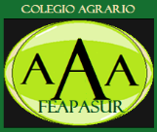 

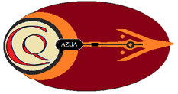

Banner/Logo:

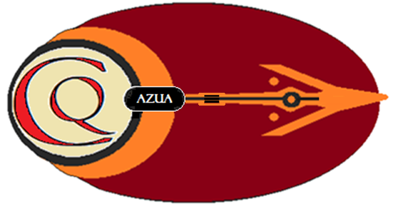

Caciquizmo de Azua

Neo-Taino Yucayeque in Azua

Founders:

Francisco Luis Gonzalez

Jesus Cueva Gonzalez

Wandy Samuel Diaz

2025

Introduction

In Azua province, Dominican Republic, we are building a semblance of an original Taino *cacicazgo.* (Azua is an important region of indigenous & colonial significance, not to mention its geologic pre-history, stemming more than 50,000,000 years.) Our Yucayeque, on the foothills of the Sierra de Ochua, on the southwestern part of the island (south of the Central Cordillera), more specifically within the *Plena de Azua*, a dry valley like central New Mexico, USA, is in an area known for its modern cultural achievements, mainly those of its most famous poet/orator, Hector J. Diaz (1910–1950): his themes include voices of African ethnicity and love ballads.

The final determination of the Taino culture on the island occurred here, with the capture *and* Christian conversion of cacique *Guarocuya* (later baptized as Enriquillo) whom prior to his death became a noteworthy Spanish partner, perhaps to ensure the survival of his people: In the opinion of some academicians, his compromised survival became a trophy of the forced acculturation of the island’s native peoples. Here is an AI excerpt:

*‘Enriquillo’s Rebellion* lasted for approximately 14 years, with Enriquillo and his followers establishing a stronghold in the rugged Bahoruco Mountains, a remote and difficult-to-access region. The rebellion was fueled by the harsh conditions of Spanish rule, including forced labor, mistreatment, and the seizure of land and resources. The uprising highlighted the resistance of the Taino people to Spanish colonialism and the brutality of the Encomienda system.

After years of conflict, a peace agreement was reached between Enriquillo and the Spanish authorities in 1533. The agreement granted freedom to Enriquillo and his followers, and they were allowed to establish a settlement within Spanish society.’

In 2024 Wandy Diaz and I began looking at Azua as a place to build innovative structures tied to the prevalent Taino themes espoused by the department of tourism. *Wandy is originally from Azua*. Jesus Gonzalez, a friend of Wandy, joined us as the major landowner of the plan, which we viewed then as an experiment in alternative living. However, it soon became apparent to us that the beauty & history of the region (and our own Taino lineages) lent themselves to something much more significant – the emergence of a reserve dedicated to indigenous education *and* community involvement. Digging deeper, we realized the need to become independent of current cultural trends relating to Haitian immigration, and possible abuses/excesses that could lead to societal harassment of those ‘illegal’ migrants; we understood that regional value systems would benefit from a holistic understanding of the prehistoric influences of Taino animism, tying those approaches to comprehensive philosophies that penetrated deeply into the post-colonial landscape.

We thusly added two school models: Feapasur Agrarian School, a cooperative school of local landowners who benefit from agrarian instruction under Jesus, an accomplished micro-farmer. And Moreu College, a role-play immersion program planned for Maine (where I own 31 acres) and had, prior to my interest in Azua, a camp for writers willing to spend several weeks in wilderness seclusion, studying the lives of Henry Thoreau, William Wordsworth - among others (American philosophers who wrote about the need to experience the transformative power of nature).

Our efforts yielded the ALIANZA AGRO-EDUCATIVA de AZUA, AAA, which tied together the Neo-Taino Tribe to Feapasur, and a Moreu College (as a *satellite* program). Our Caciquizmo becoming the umbrella for the ethics of our triple alliance. See diagram on next page:

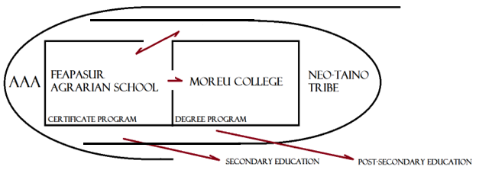

Explanation of Graphic:

AAA (Alianza Agri-educativa de Azua) is the governing organization of 3 educational experiments: **Caciquizmo de Azua** (our Neo-Taino Tribe and its Government), **Feapasur** (a semi-independent agrarian school which provides referrals to secondary educational venues), and **Moreu College** our advanced degree-granting college.

FEAPASUR (under Wandy Diaz) works with local micro-farmers to learn the required economics to prosper & grow their individual farms and work in harmony within the cooperative. Its agrarian school (under Jesus Gonzalez) is an optional feature for Feapasur members desiring to complete their secondary education, adding vocational features to their required studies.

NEO-TAINO TRIBE (Caciquizmo de Azua) provides an entry point to a college education to interested Feapasur members (all others must enroll as coop members in order to gain Neo-Taino membership [more on those requirements later]). Vested Neo-Taino members are *true* tribal members under our constitution, whose vested inclusion is organizationally irrevocable.

MOREU COLLEGE (under Francisco Luis Gonzalez) provides an associate degree to graduates of the Feapasur Agrarian School. A diploma from the agrarian school is equivalent (by Dominican law) to secondary school attainment, and can be used to matriculate into Moreu College, but only if the prospective student is a Neo-Taino tribal member.

AAA Academics

FEAPASUR (these vocational classes are added to the town’s secondary requirements, to obtain a neglected or postponed diploma):

1. Geology
2. Soil
3. Light applications
4. Underground mushroom cultures
5. Wells, rainwater applications, and drip systems
6. Pests
7. Cultivation & profit-production of Banana and Plantain

8. Cultivation & profit-production of Melon and Cantaloupe

9. Cultivation & profit-production of Yuca and other root products: carrots, onion, and sweet potato

10. Herbs for Yucayeque use: Cilantro and others (for teas).

11. Tomato

12. Beet

MOREU COLLEGE Requires a Secondary diploma):

1. Indigenous American Philosophy (8 classes)
2. Indigenous Philosophy (5 classes)
3. Perennial Philosophy (5 classes)
4. Perennial Theology (5 classes)
5. Applied Ethics (5 classes)

Caciquizmo de Azua

Our Neo-Taino Governing System

Cacique Autocracy: based on traditional yucayeque governance (as researched from Spanish sources and sacred, passed-down, oral traditions).

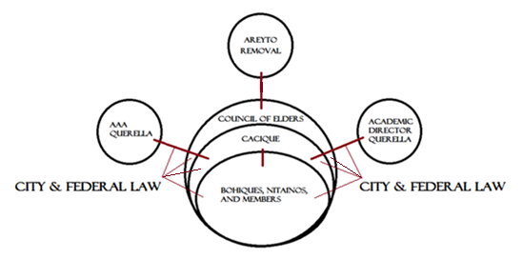

1. **Cacique’s Authority is Mitigated**:

* In the Dominican Republic, federal & provincial laws apply. The president of the AAA, or the educational directors of Feapasur or Moreu College can report serious cacique-misconduct to the local government. They can then petition the Council of Elders for *immediate* removal of the cacique, replacing Cacique with a willing Bohique (if no Bohique volunteers for the post, it must be filled by the oldest member of the council). Cacique may return to power if vindicated by the courts AND then wins a re-instatement vote by the Council; the Council of Elders is not tied to the judicial verdict and makes *independent decision* for the ‘good of the tribe’.
* Council of Elders (8 oldest tribal members over 18 years old) can veto and/or remove existing Cacique through UNANIMOUS VOTE. The council can also veto Bohique’s command decisions, and Nitaino command decisions, unanimously (Bohiques and Nitainos can *only* be removed by Cacique command [removal is by demotion to *member-only* ranking]). The Council of Elders is not beyond reproach – the entire 8-member council may be replaced if a special AREYTO ceremony is held and the entire body is removed in its entirety by group acclimation, even if the entire council is not present for the act.

Bohiques, Nitainos, or Members cannot be removed by group

acclimation: They are protected by the Cacique’s time-vested

authority. The Council of Elders holds its own Areyto from time-

to-time to listen to problems within the Yucayeque and provide

guidance.

**Note**: In our Neo-Taino model, while the Cacique appears to have total authority, his/her authority is checked by the AAA invoking local laws (school directors can also do that), and in the event of yucayeque injustice or favoritism, by the Council of Elders which can remove him temporarily or permanently. Therefore, the Cacique authority is maintained by his transparency, wise use of power, caring demeanor, and loyalty to the tribe-as-a-whole.

1. **Bohiques**:

In our Neo-Taino model, Bohiques are spiritual individuals from various local real-world traditions (regardless of credo). *There is one for every 500 members*; they are chosen from the general membership by the Cacique and must be open to new ideas (or old ideas): must be ecumenical or multi-denominational if Christians. Bohiques must be enrolled in Moreu College to understand the mystical side of all religions and are forbidden to proselytize their individual beliefs within the role-play-like confines of the Yucayeque. Bohiques can be removed at the sole will of the Cacique with no process of appeal. In public life, outside the Caciquizmo (yuvayeque), the Bohique is free to express his beliefs, but will be held accountable by the Council of Elders for fomenting internal division created by their unguarded words or actions.

1. **Nitainos**:

In our Neo-Taino model, Nitainos are the close relatives and friends of the Cacique, creating a type of political base or party, we differ from the ancient model by assigning Nitainos specific roles according to their interests and skills, assigning them to tasks within the entire AAA system, by limiting their numbers, and providing ongoing elder supervision. By our constitution there are 10 Nitainos for every 1,000 members, each with his/her specific role-to-play. Roles may involve the following activities (in alphabetical order):

* Artisans
* Care of Ceremonial Sites
* Care and/or training of Animals
* Community Liaisons
* Construction Lead-persons
* Farming Lead-persons
* Musicians
* Personal Assistants to Cacique, Bohiques, or the Council of Elders
* Photographer Scouts
* Storytellers
* Teachers or Assistant Teachers
* Yucayeque Security

1. **Roles of Elders**:

By our constitutional definition, elders are the oldest members of our yucayeque. The oldest 28-members of our tribe have special, automatic roles:

* Oldest 1 through 8:

Automatic Members of our Council of Elders.

* Next Oldest 9 through 20:

Automatic Personal Assistants or Supervisors to every Nitaino.

1. **Ceremonial Sites** – these are Planned Sacred Places:

* Place of Memories (memorial/cemetery of former Caciques, Bohiques, Nitainos or esteemed Members)
* Place of Healing (Healing ceremonies must have a Bohique present)
* Place of Areytos
* Place of NHI (non-human-intelligence)

1. **Neo-Taino Architectural Innovation**:

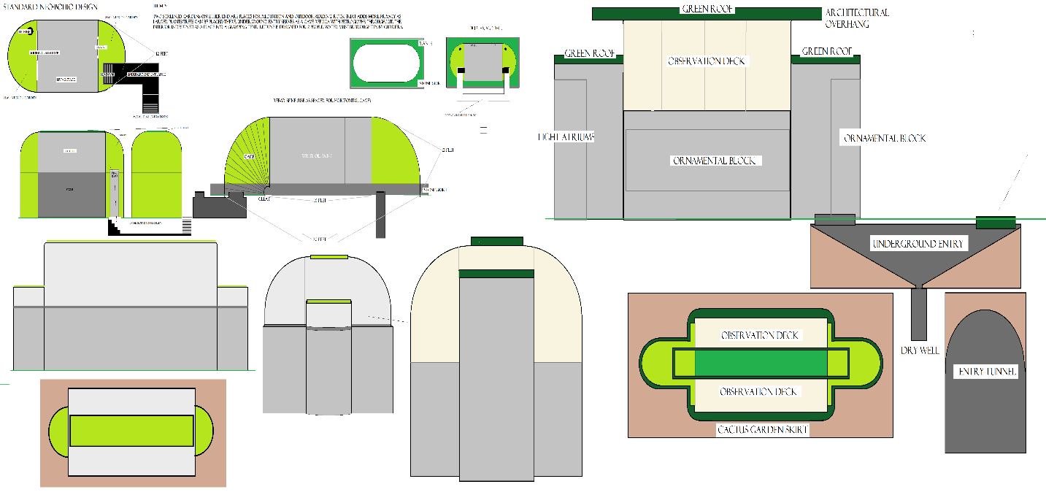

Our proposed buildings do not reflect the past nor the present, but hint at the ideal forms of our future connection with ourselves, with nature, and with the universe. Types of structures:

* Artificial Caves & Petroglyphs
* Ball Court
* Bohios
* Cacique House
* Ceremonial Sites
* Congregational Hall
* One-person Solo Units/camps

1. **Service Dogs** – training & usage:

We plan on having 20 canines ready by 2027, trained as companions to our solo retreatants (see pedagogical features on section 8 [Learning Systems & Methods]). We have eight dogs currently.



BOXER on watch duty

(alpha male)

1. **Learning Systems & Methods**:



* **Experiential Learning** – learning by doing:

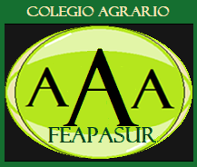

* **Role-play & Sociodrama** – learning by imagination:



* **Service Learning** – learning by serving:



* **Solo-transformative** – learning in solitude:

1. **Summary**:

Our learning triad (Feapasur Agrarian School, Moreu College of philosophy & ethics, and the Caciquizmo of Azua (our Neo-Taino tribe) present the best possible modes for the retention of complex interdisciplinary cognitive and mystical material – using tested experiential, service learning, and solo-transformative methodologies. This mix is important because we are teaching an entire community through individuals who are not educationally homogeneous but an admixture of pedagogical skillsets and diverse motivations: Our Alliance is an experiment in *practical holistic (educational) practice*, whose goal is to metamorphose a stagnant sociocultural environment, invigorating it with insight and new ways of thinking.